Assignment 3

Representing and communicating foreign born population in the US

EXPLORERS EUROLAB 2O2O
Subject: Environmental Mapping Strategy [EMS]
Prof: Patxi Escobar
Year: 2020

Preliminaries
The aim consists on exploring techniques related to cartographic transformations of position (CTP) or cartograms to better represent foreign born population.
As a continuation of the topic tackled in assignment 2, human migrations, different cartogram techniques will be put into practice.
When users are familiar with the shape and other characteristics of the represented area, distortions of such shape based on thematic conditions, might be an excellent communication tool.
In this assignment we are going to look at population composition, nationals and foreign born, in the States of the USA.
In the solving of the assignment, students are confronted to tasks related to cartographic projections, data search, map generalization, semiotics, interval definition, and distortion of the cartographic base based on thematic attributes.

Problem
Traditional mapping techniques are not sufficiently expressive as to efficiently communicate demographic characteristics such as population composition based on place of origin.

Objective
To design and to produce a series of cartograms showing foreign born population in the US.
Precisely, you are asked to produce Dorling’s and Gastner & Newman maps.

Data
Both US cartographic base and required thematic data are provided (check Patxi’s website or Drive folder).
In case you are interested in downloading the data from their original sources, go to the following URL:
The cartographic base of the state boundaries https://tapiquen-sig.jimdofree.com/english-version/free-downloads/united-states/.
For context purposes, we will use the layers “countries”, “rivers” and “lakes” we had since assignment 1.

The thematic data are provided in the following web sites:
- Foreign-born population in the US. United States Census Bureau https://data.census.gov/cedsci/

Recommended software: ArcGis.
You can also try Geoda (https://geodacenter.github.io/download.html or https://spatial.uchicago.edu/software) and DARCY (http://thema.univ-fcomte.fr/production/logiciels/16-categories-en-francais/cat-productions-fr/cat-logiciels-fr/294-art-darcy).

Format
This assignment will be materialized in a series of maps in JPEG format. Below there are some examples of what the maps would normally look like.
The maps will be sent to Patxi by email (patxiescobar@gmail.com).

Date
The assignment is due on the 2nd June 2020.

Guidelines
Detailed guidelines including text, images, and videos are provided in the file “Practical Guide to Assignment 3.ppt”.
Theoretical content related to this assignment is included in the following files:
- Cartograms.ppt

Traditional representation
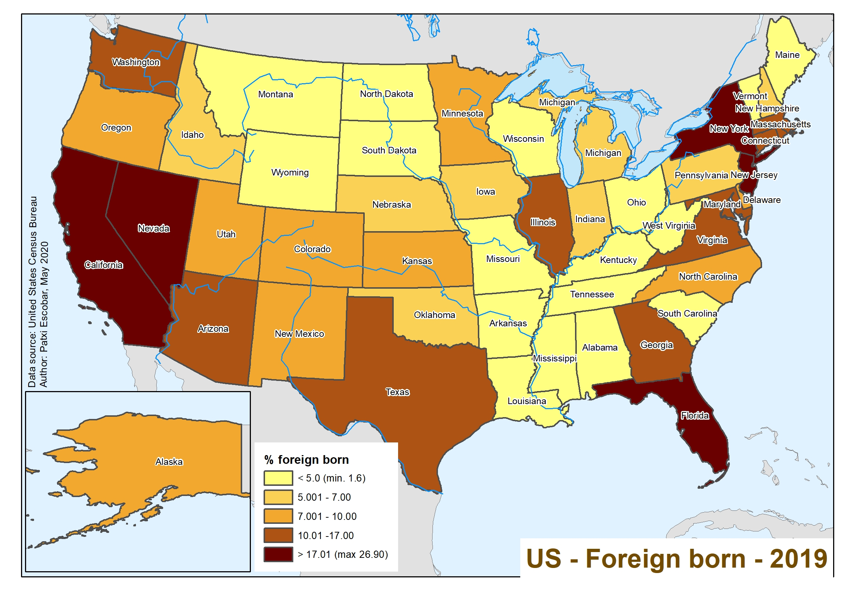

Dorling’s representation
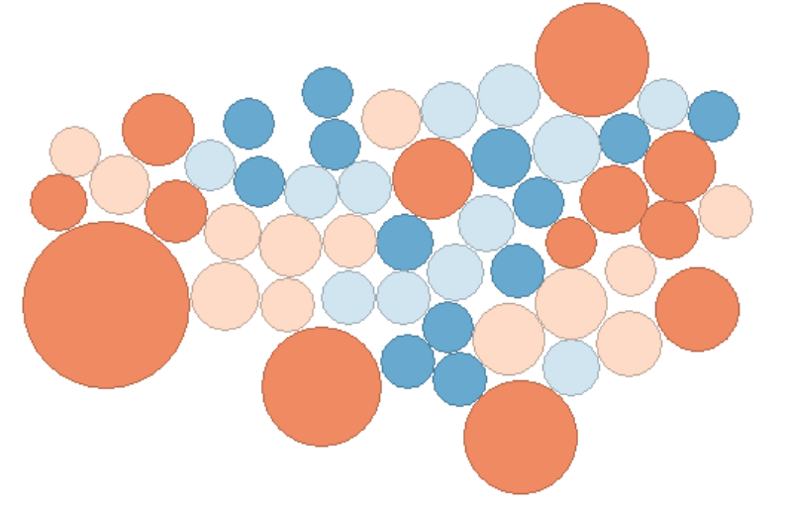

Gastner & Newman
