Assignment 5

Representing and communicating 3D realistic animated urban environments – Animated Geovisualization

EXPLORERS EUROLAB 2O2O
Subject: Environmental Mapping Strategy [EMS]
Prof: Patxi Escobar
Year: 2020

Preliminaries
The aim of this assignment is to explore scene animation possibilities in GIS.
Visualizing 3D realistic models and creating videos to allow exploration around the represented area is useful when it comes to communicate information about the environment that no longer exist (archaeological sites) or that has not yet been built (planned urban developments). Also, 3d realistic animated models can be used for gaming purposes, for sport training or to facilitate public participation.
Traditional mapping is not suitable to represent 3D realistic environments. In this assignment we will work on the edges of traditional mapping and architectural design.
Students are confronted to tasks related to cartographic projections, scales, generalization, semiotics, interval definition, 3D modelling, realistic rendering, scene animations and animated objects.

Problem
Very often, humans have to make decisions about environments that no longer exist, that haven’t yet been built or that are far from us and therefore we can’t see them.
This is the case with the present assignment. We are asked to build a 3D realistic model of a street in Alcala that was recently transformed into a pedestrian area. We are asked to show the “before” and “after”.

Objective*
To design and to produce a series of videos to show the transformation of Calle Libreros in Alcalá de Henares.
Before After
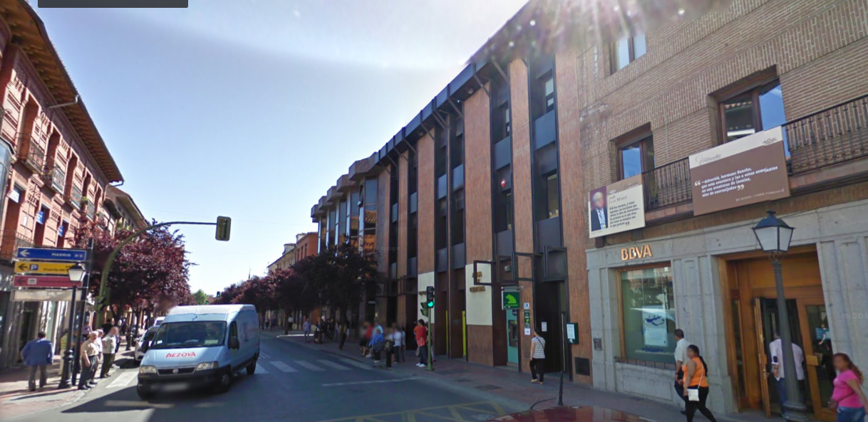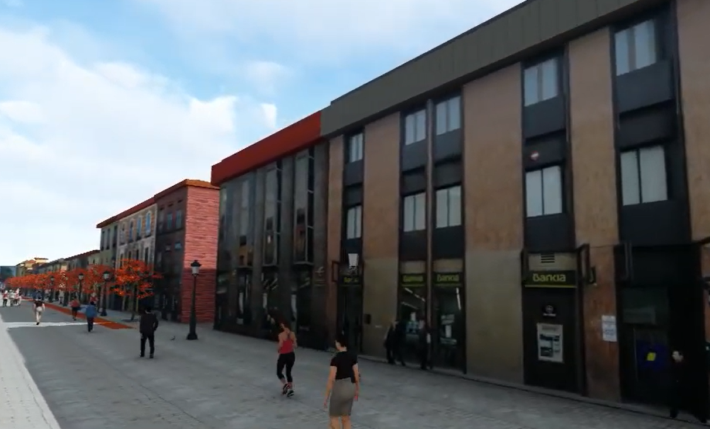
____
*Students are free to choose a different environment.

Data
A zipped file “Data_Animacion-3D.zip” containing all necessary data is provided.
Recommended software: ArcGis. Module ArcScene.

Format
This assignment will be materialized in a series of videos published in Vimeo or in Youtube.
The URL of those animated maps will be sent to Patxi by email (patxiescobar@gmail.com).

Date
The assignment is due on the 16th June 2020.

Guidelines
Detailed guidelines including text, images, and videos are provided in the file “Practical Guide to Assignment 5.ppt”.
Theoretical content related to this assignment is included in the following file:
- Geoviz_Intro_general.ppt

